

**R. C. Patel Educational Trust's**

**Institute of Management Research and Development**

**Quality Education for Nourishing Tomorrow’s IT & Management, Professionals**

**A Project Report on:**

**“Olympics Data Analysis Dashboard 1896 to 2022”**

**Submitted by-**

**Miss. Vaishnavi Tukaram Dorik**

**PRN : 2022015400119411**

**E-mail:- vaishnavidori@gmail.com**

**In Partial Fulfillment of**

**Bachelor Of Computer Application**

**-Guide by-**

**Dr. D. M. Marathe**

**-Submitted to-**

##### **R. C. Patel Institute of Management Research and Development, Shirpur**

**-Affiliated to**

**Kavayatri Bahinabai Chaudhari North Maharashtra University, Jalgaon.**

**[Academic Year 2024-2025]**

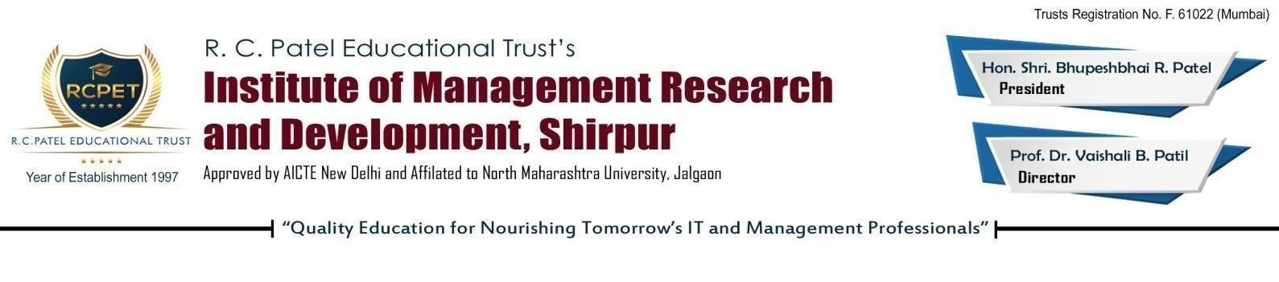**CERTIFICATE**

This is to certify that Vaishnavi Tukaram Dori has successfully completed his project entitled **“Olympics Data Analysis Dashboard 1896 to 2022”**as a partial fulfilment of the requirements for the degree of Bachelor of Computer Application (BCA) at North Maharashtra University, Jalgaon.

This performance and the system are up to mark and I am satisfied with the same.

Date:-

**Dr. D. M. Marathe Dr. Tushar R. Patel**

Project Guide (HOD of UG Department)

Internal Examiner:

External Examiner:

**DECLARATION…**

I hereby declare that the project entitled analysis for Online Library Management System. Is prepared by me under the guidance **of Prof. Dr. D. M. Marathe.**

I also declare that this project is towards the partial fulfillment of requirement for the Bachelor of Computer Application of Jalgaon University has been the result of my own efforts and this project has been formed a basis for the award of my other degree or any other university.

Thank you.

Place- Shirpur

Date - / /

**ACKNOWLEDGEMENT...**

It is with great pleasure that I take this opportunity to express my respect and gratitude to those who helped me in making this project a success.

I am sincerely thankful to our respected Director of IMRD, **Prof. Dr. Vaishali B. Patil**, for her invaluable support in the successful completion of this project by providing essential resources and guidance.

I have developed this project with the help of the faculty members of our institute, and I am extremely grateful to all of them for their constant support and encouragement.

I would also like to extend my gratitude to the Head of the Department UG, **Dr. Tushar R. Patel**, for his timely suggestions, guidance, and encouragement throughout the project.

Furthermore, I express my sincerest and deepest sense of gratitude to my guide, **Dr.D. M. Marathe** ,for her valuable assistance, guidance, and cooperation in successfully carrying out this project.

Lastly, I extend my heartfelt thanks to everyone who has indirectly contributed to the completion of this report and played a role in helping me achieve my goals.

**Name : Vaishnavi Tukaram Dorik**

**INDEX**

|  |  |
| --- | --- |
| **Content** | **Page** |
| **1 : Introduction** | 6 |
| * 1. Introduction of Data Analytics and Data Science | 6 |
| 1.2 Types of project | 7 |
| 1.3 Problem Statement | 7 |
| 1.4 Platforms and Tools of Use | 8 |
| 1.5 Objectives | 9 |
| 1.6 SDLC in Data Science Projects | 10 |
| **2 : Data Collection ,Exploration & Pre-processing** | 12 |
| * 1. Data Collection Methods | 12 |
| * 1. Exploratory Data Analytics | 12 |
| 2.3 Handling Missing Values and Outliers | 14 |
| 2.4 Feature Engineering and Selection | 15 |
| **3 : Data Cleaning ,Transformation and Visualization** | 16 |
| 3.1 Data Normalization ,Transforming Data | 16 |
| 3.2 Data Visualization Techniques | 16 |
| 3.3 Introduction to Visualization Tools | 19 |
| **4 : Predictive Modelling and Dashboard Creation** | 22 |
| 4.1 Concept of Dashboard or Reports | 22 |
| 4.2 Design the Layouts (Charts and Graphs) | 22 |
| 4.3 Add filters, slicers etc. | 25 |
| 4.4 Test and Publish | 27 |
| **5 : Results Interpretation, Reporting** | 32 |
| * 1. Interpreting Model Result Decision | 32 |
| * 1. Visualizations for Results | 33 |
| 5.3 Summary of findings | 34 |
| **6 : Conclusion and References(Future Scope)** | 37 |
| 6.1 Recommendation | 37 |
| 6.2 Future Enhancements | 37 |
| 6.3 Communicating results to Stakeholders | 37 |
| **6.4 References** | 39 |

**Olympics Data Analysis Dashboard**

**1896 to 2022**

**Chapter 1 : Introduction**

**1.1: Introduction of Data Analytics and Data Science :**

* **Data Analytics** :

Analyzing raw data to find trends, patterns, and important information is known as data analytics. By using both historical and current data, it facilitates the process of making better judgments.

• **Goal:** To address certain issues or provide answers to specific queries.

• **Tools:** Excel, Power BI, and SQL are examples of common tools.   
• **Examples include:**

• Gaining insight into a company's sales performance.   
• Being aware of consumer preferences.

* **Data Science:**

Programming, statistics, and domain expertise are all used in the broader discipline of data science to extract meaning and forecast outcomes from data.   
• **Goal**: To create models, forecast trends, and address difficult problems.

•**Tools:** Includes Python, R, and Machine Learning techniques.

•**Examples:**

* + Predicting how customers will behave.
  + Creating recommendation systems like the ones used by Netflix.

**Key Difference :**

* **Data Analytics :** Focuses on understanding "What happened?"
* **Data Science :** Explores "Why did it happen?" and "What will happen next?
  1. **: Types of project**

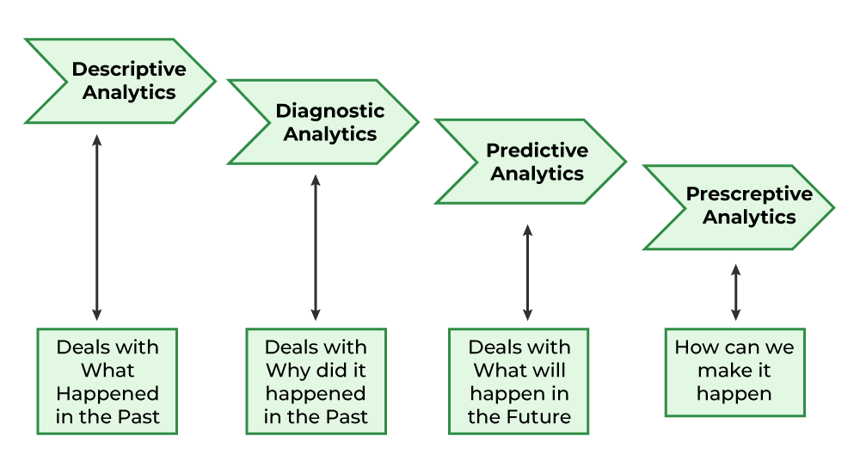

### Best Fit for the Project:

* **“Descriptive Analytics”** and “**Diagnostic Analytics”** are most suitable as they align with the project's goal of presenting and understanding historical and current Olympic data.
* **“Predictive Analytics”** can be included if advanced forecasting models are developed.
* **Problem Statement :**

The Olympics is a global event that brings together athletes, nations, and spectators, showcasing incredible performances and fostering international unity.

However, analyzing and interpreting the vast amount of data generated during the games can be a complex task.

This includes tracking medal tallies, evaluating athlete performances, and understanding trends across different sports and countries.

The lack of a comprehensive and user-friendly platform to consolidate and visualize this data poses a challenge for analysts, researchers, and enthusiasts.

* **Proposal :**

To address this issue, the **Olympics Dashboard 2024** aims to provide a centralized, interactive, and visually engaging solution.

This project will streamline data analysis by integrating historical and real-time data, enabling users to explore insights such as country-wise achievements, athlete statistics, and event-specific performances.

The goal is to enhance data accessibility and decision-making for a wide range of stakeholders, including sports organizations, researchers, and fans.

**1.3: Platforms and Tools Used**

**1.Power BI**

To create aesthetically pleasing and dynamic dashboards for Olympic data analysis.  
**For example**, a map, graph, or chart .

**2. Microsoft Excel**

• For effective dataset organization, pre-processing, and basic data cleaning.

**3. Python**

• To use libraries like Pandas, Matplotlib, and Seaborn to handle big datasets, execute algorithms, and carry out sophisticated data analysis.

**4. SQL**

• For database management and searching to retrieve pertinent Olympic data.

**5. Kaggle**

•Using Kaggle to obtain Olympic datasets that are openly accessible for incorporation into the project.

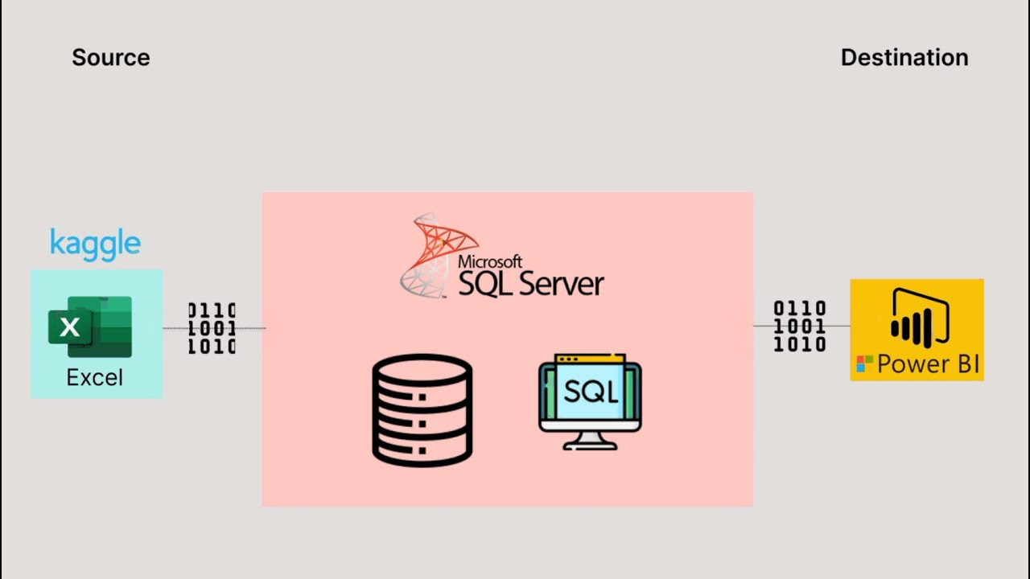

* **Objectives**

**1. Establish a Centralized Dashboard:**

• Provide a unified platform for the visualization and analysis of all pertinent Olympic data.

**2. Offer Visualizations That Are Easy to Use:**  
•To make data exploration simple and interesting, use interactive graphs, charts, and filters.

**3. Make Comparative Analysis Possible:**

• Make it easier to compare nations, athletes, and sports across various Olympic events and years.

**4. Emphasize Trends and Insights:**

• Spot trends in the rankings of nations, athlete performance, and medal distribution over time.

**5. Support Real-Time Data Updates:**

• Verify that the dashboard is capable of incorporating fresh data, including the results of Olympic events in real time.

**6. Strengthen Decision-Making:**

• Offer businesses, researchers, and sports analysts practical insights to guide strategies and boost output.

**7. Display Analytical Skills:**

• Use Power BI, Python, and SQL to show off your proficiency in data collecting, processing, and visualization.

**8. Advocate for accessibility:**   
 •Create the dashboard with a broad user base in mind, including researchers, policymakers, and sports fans.

**1.4 : SDLC in Data Science Projects**

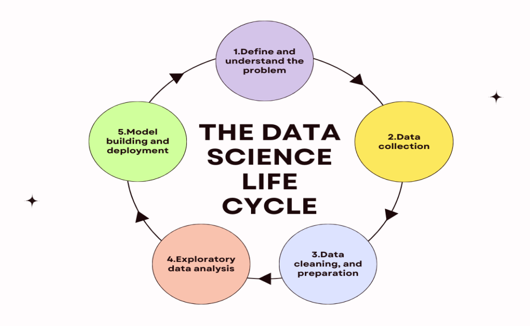

**1. Definition of the Problem**   
• Specify the project's goals and main issue.  
Determine the scope and important success measures in collaboration with stakeholders.   
  
**2. Information Gathering**   
•Gather pertinent information from a range of sources, such as surveys, APIs, and public databases.   
Make sure the data gives the required information and is in line with the issue.

**3. Preparing the data** •Handle duplicates, outliers, and missing values to clean up the data.  
 • Prepare the data for analysis by transforming and structuring it, Including by encoding or normalizing attributes.  
  
 **4. Exploratory Data Analysis (EDA):**

•Use statistical techniques and visual aids to examine the data.  
Determine the data's main trends, correlations, and irregularities.

**5. Development of Models**• Choose machine learning methods that are appropriate for the given task.  
• Use the training data to train models, adjust parameters, and assess results.

**6. Testing and Model Evaluation**  
•.Analyze the model's performance and accuracy with the right measures.  
•To make sure the model is generalizable, test it on fresh, untested data.

**7. Model Implementation**• Integrate the trained model with pertinent platforms or applications, or deploy it into production.  
•If applicable, make sure the model runs effectively in real-time.   
  
**8. Model Upkeep and Monitoring**   
• Keep an eye on the model's performance to make sure it stays correct.   
•To keep the model current, it should be updated and retrained whenever new data becomes available.

The project advances systematically by adhering to these Data Science SDLC phases, guaranteeing high-quality outcomes and long-term efficacy.

**Chapter 2 : Data Collection ,Exploration and Pre-processing**

**2.1 : Data Collection , Exploration and Pre-processing**

Any project must include data collecting in order to ensure that pertinent and reliable information is obtained for analysis and decision-making. The sort of project, its goals, and the resources at hand all influence the data collection techniques chosen.

* **Data Collection Methods :**

**1.Secondary Data Collection**:

**Definition:** Data obtained from existing sources, making it cost-effective and time-saving.

**Methods:**

•Public Datasets & Online Repositories

•Pre-collected and structured data from sources like **Kaggle (**<https://www.kaggle.com>**)**, UCI, and government databases.

•Historical Olympic data, medal tallies, and athlete statistics can be downloaded for analysis.

2.**Web Scraping:**

•Extracting data from websites using Python libraries like BeautifulSoup and Scrapy.

•Used when real-time data is needed from sources like news sites and e-commerce platforms.

* 1. **: Exploratory Data Analytics**

Exploratory Data Analysis (EDA) helps in understanding the structure, patterns, and key insights from the Olympic dataset before building the dashboard or models.

**1. Recognize the Data Structure**• **Action:** Examine the dataset to determine which columns (such as Athlete Name, Country, Sport, Event, Medal Type, and Year) have meanings.  
• **Goal:** Recognize the various data types (numerical, category, and date) and how they relate to your study.

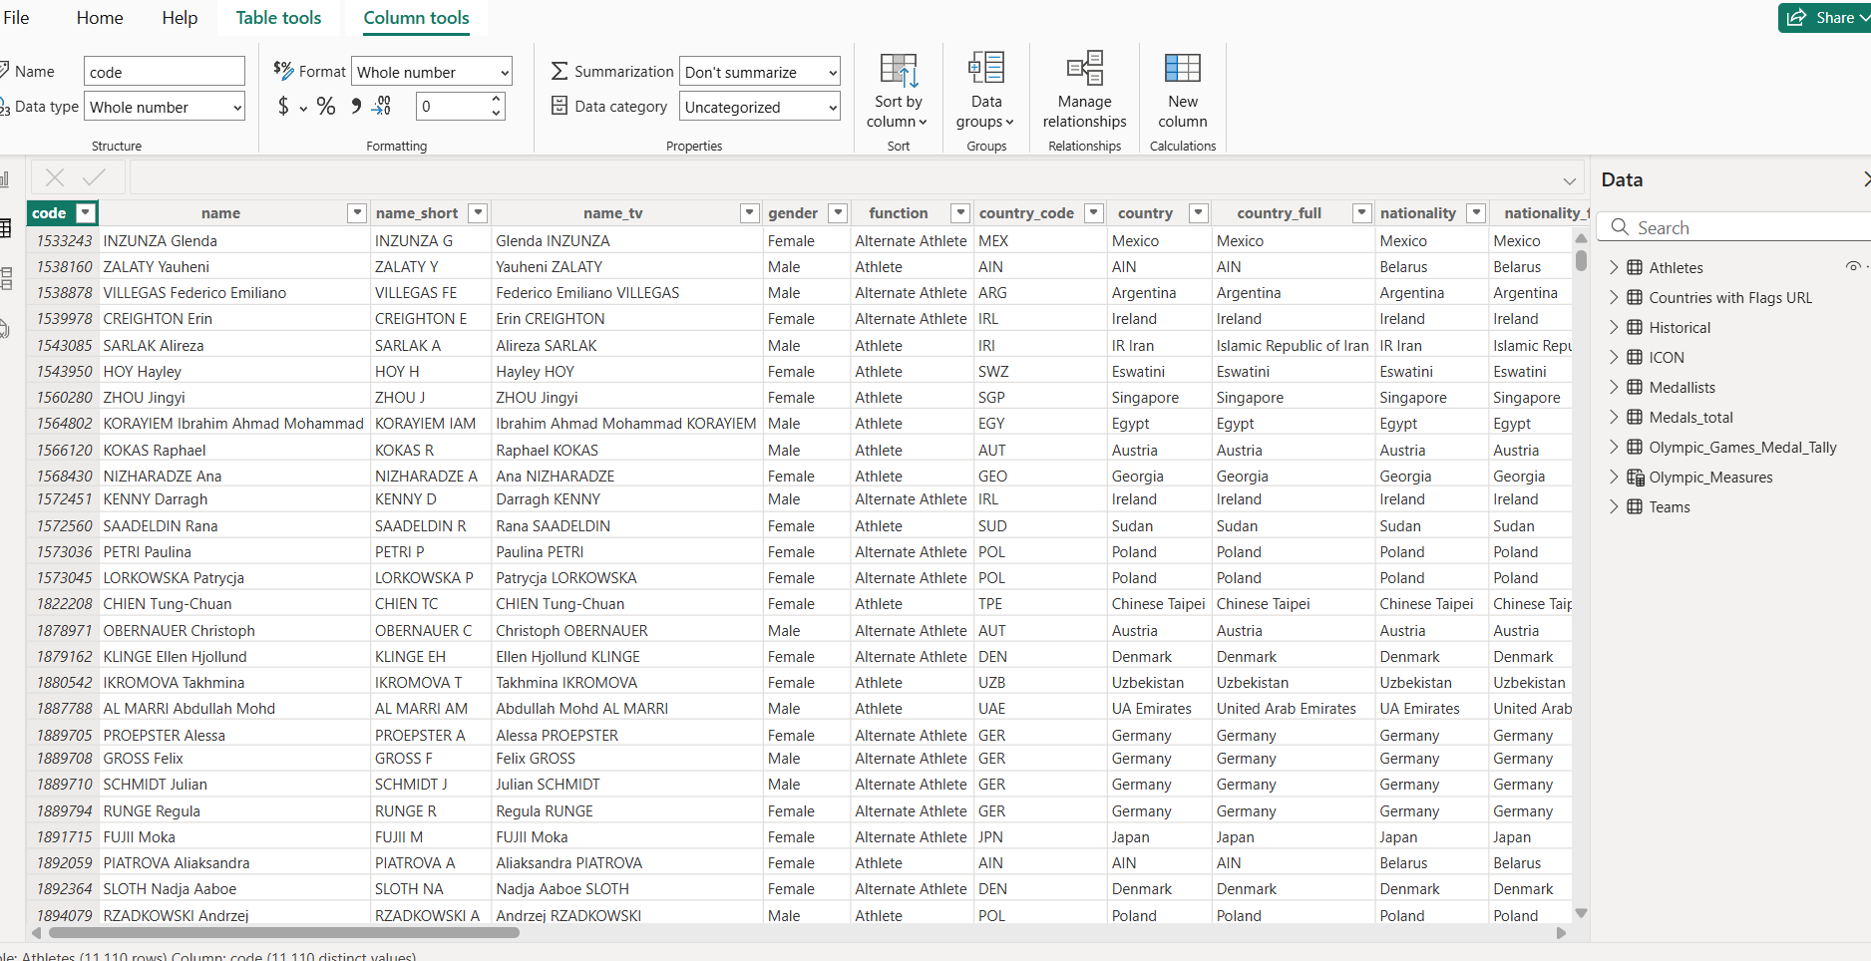

**2. Data Preparation and Cleaning**  
• **Take action:** Deal with inconsistent entries, duplication, and missing data.   
• **For instance,** eliminate duplicate athlete records or include "No Medal" for any missing medal types.   
• **Goal:** Make sure the data is accurate and tidy for analysis.

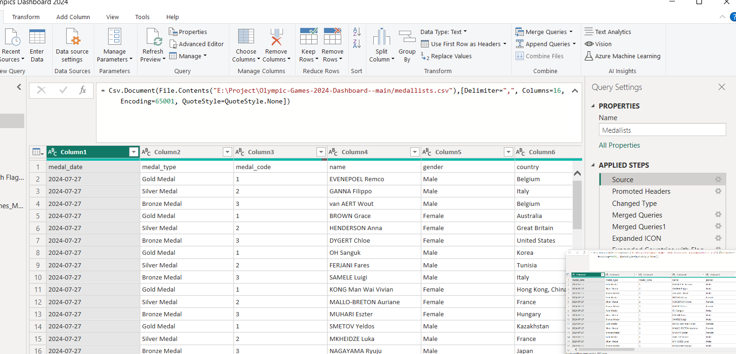

**3. Summarize the Data:**

• **Take Action:** To obtain a summary of the data, apply statistical techniques.  
• **As an example,** count how many athletes, nations, and events there are in the dataset.   
• **Goal:** Obtain a high-level summary of the information contained in the dataset.

**4. Power BI Visualizations:**

• Create interactive visualizations like bar charts for medal distribution by importing the cleansed dataset into Power BI.   
• Line charts that show trends in performance over time.   
Maps showing medal counts by nation; pie charts showing medal categories by sport.

EDA on the Olympic database gives you valuable insights into the data, which you can use to create an engaging dashboard and draw conclusions based on facts.

* 1. **: Handling Missing Values and Outliers**

**1.What is a Missing Value?**

Data points that are missing for a particular variable in a dataset are known as missing values. They can be shown as null values, blank cells, or special symbols like "NA" or "unknown," among other ways. These omitted data items provide a serious problem for data analysis and may produce biased or erroneous findings.

### Handling Missing Values & Outliers in the Olympic Database :

**1. Taking care of missing values**   
• **Find Missing Data:** To find columns with missing values (such as Athlete Name, Medal Type, or Country), use tools like Python or Power BI's data profiling capability.   
 **2. Eliminate Rows/Columns**: If a row or column contains an excessive number of missing values and is not essential to the analysis, think about removing it.   
•**For instance,** if a record cannot be recovered, remove it if the Event Name is missing.

**3. Flag Missing Data:** To identify rows with missing data for upcoming analysis, create a new column.

#### ****Using Power BI for Handling Missing Values and Outliers :****

1.**Data cleaning in Power BI (Power Query):**

•Fill in missing values with the "Replace Values" option.  
 •Use filters to find and handle rows that contain extreme or null values.   
  
**2.Visual Analysis of Outliers:**

• To visualize and draw attention to outliers, use Power BI's box plots or scatter plots.   
• As an illustration, show the age distribution of athletes and highlight any numbers that are abnormally high or low.

### : Feature Engineering and Selection

* **Feature Engineering:**

This involves creating new features or transforming existing ones to improve the dataset's utility for analysis or modeling.

**1.Medal Counts:**

•Add columns for Total Medals, Gold Medals, Silver Medals, and Bronze Medals by grouping data by countries or athletes.

•**Example:** Calculate how many gold medals each country has won in each Olympic year.

**2.Participation Metrics:**

•Create features like "Years Participated" or "Total Events Competed" for athletes or countries.

•**Example:** Add a column showing the number of Olympic years an athlete or country has participated.

**Chapter 3 : Data Cleaning ,Transformation and Visualization**

**3.1 : Data Normalization and Transforming Data**

"Data Normalization" refers to the process of structuring and standardizing data by removing redundancies and inconsistencies”.

#### Steps:

**1.Identify Columns for Normalization:**

Choose the columns that need to be normalized. For example, "Athlete Age," "Total Medals," or "Athletes per Country."  
**2. Use scaling techniques.   
3. Normalization of Z-Score.**  
• **Data Transformation:**

To make data better suited for analysis, data transformation entails changing the data's structure or format.

**3.2:** **Data Visualization Techniques**

**Data Visualization** is the process of representing data and information in a graphical or visual format, such as charts, graphs, and maps. It helps to identify patterns, trends, and insights in complex datasets, making data easier to understand and analyse.

**1.Cards :** It is use for showing total medals like : Gold, Silver and Bronze.

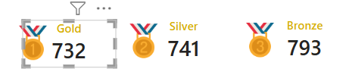

**2.Stacker Bar Chart :** It is also use for showing the “Athlete by there country and Gender “.

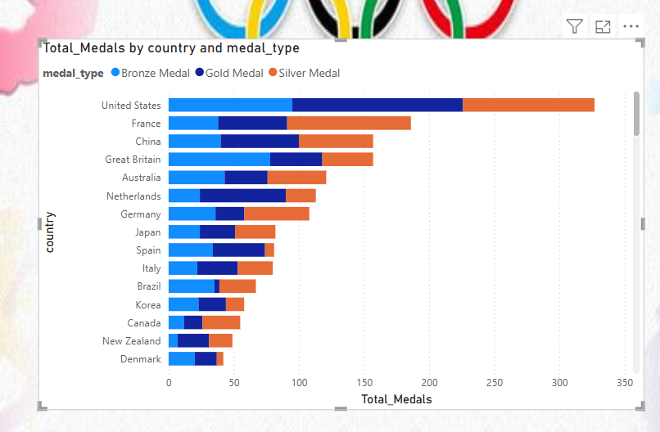

**3.Slicer :** It was show country with the help of slicer like : India, Japan , Italy, etc…

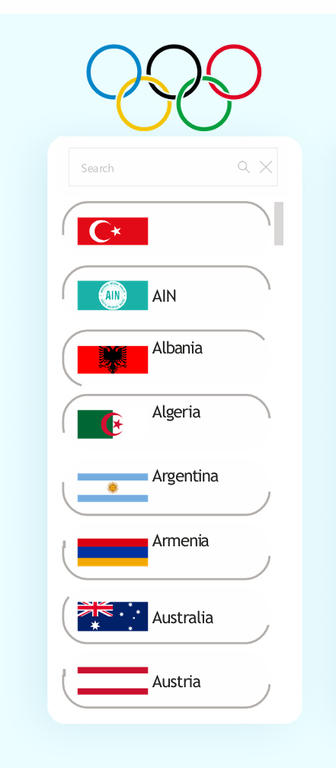

**4.Map :** Great for location – based data visualizations.

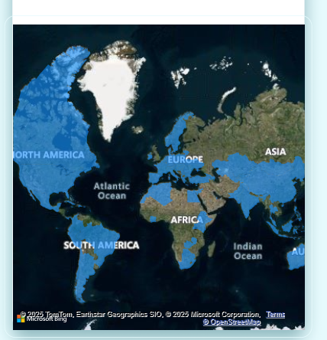

**5.Area Chart** : Effective for visualization cumulative trends.

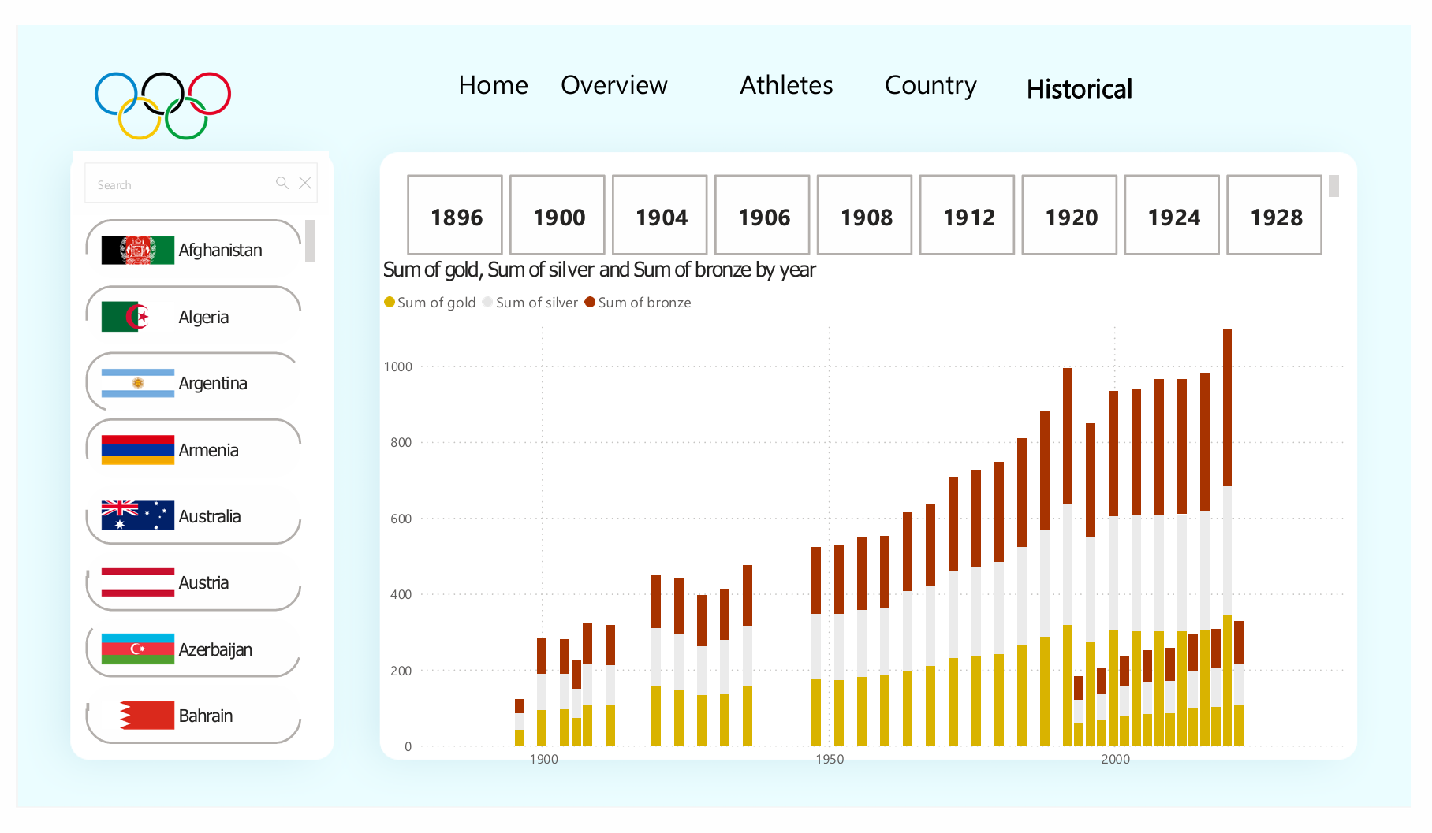

**6.Clustered Column Chart** : It is show athletes counts by gender and age.

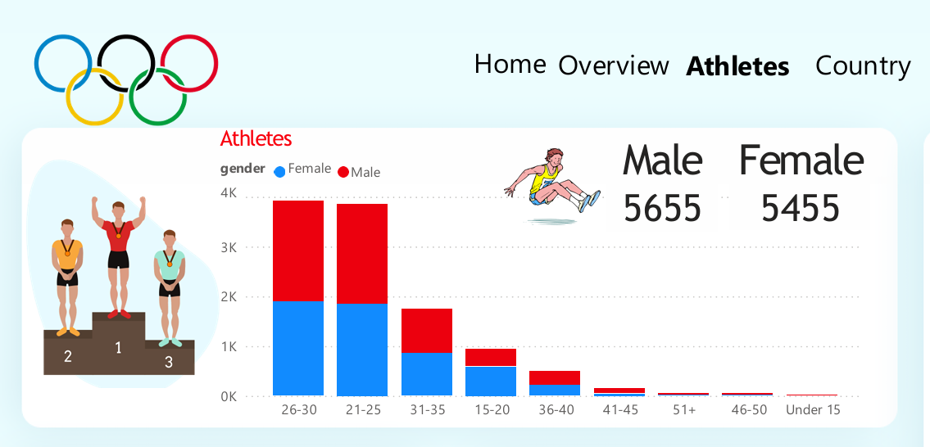

**7. Button Slicer :** A vertical list slicer with sports name’s like : Swimming, BasketBall,Gymnasticas,etc….

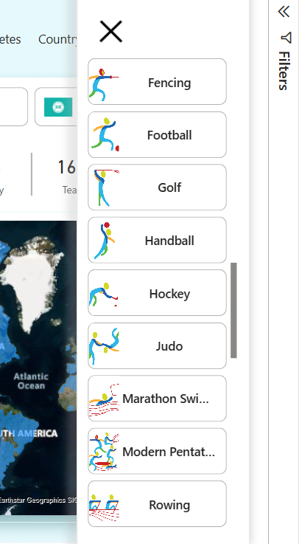

### ****3.3 : Introduction to Visualization Tools****

Software programs known as data visualization tools assist in converting unprocessed data into graphical representations like dashboards, maps, graphs, and charts. These tools are essential for data analysis, reporting, and decision-making because they help users comprehend complicated datasets and spot trends, patterns, and insights.

### ****Importance of Visualization Tools****

1.**Improve Data Understanding:** Transforms huge datasets into visually understandable representations.

2.**Enhance Decision-Making:** Assists analysts and corporations in reaching well-informed conclusions.

3.**Spot Trends and Patterns:** These provide information that may not be apparent in unprocessed data.   
  
4.**Interactive Exploration:** This feature lets users dynamically filter, delve down, and examine data.

### • ****Popular Data Visualization Tools****

#### ****Power BI****

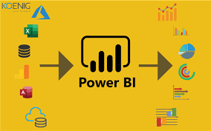

**•**Microsoft created this popular corporate intelligence and analytics tool, which offers real-time reports, interactive dashboards, and AI-driven insights.

**•**Greatest for real-time monitoring, financial reports, and corporate analytics.

### •****Power BI Visuals for Olympics Dashboard:****

**1.Map Chart:** To visualize country-wise medal distribution.

**• Parameters:** Country, Total Medals.

**2.Area Chart:** To display **year-wise medal trends**.

**• Parameters:** Year (X-axis), Medal Count (Y-axis).

**3.Bar/Column Chart:** To compare **top-performing countries** or **most successful athletes**.

**• Parameters:** Country/Sport (X-axis), Medal Count (Y-axis).

**4.Slicer (Filter Control):** To filter data by **Year**, **Sport**, or **Country** dynamically.

**•Parameters:** Year, Sport, Country.

#### ****Excel (with Data Visualization Features)****



* Provides **basic to advanced charts and pivot tables** for quick data insights.
* Includes tools like **Power Query, Power Pivot, and Power View** for advanced reporting.
* Best for **small business analytics and simple data reporting**.

**Chapter 4 : Predictive Modelling and Dashboard Creation**

**4.1 : Concept of Dashboard and Reports**

Organizations rely on dashboards and reports to provide insights in an intelligible manner since data is essential to decision-making. Despite having comparable functions, their designs, uses, and functionalities varied greatly.

## ****What is a Dashboard?****

A dashboard is a visual depiction of important data points that enables real-time information analysis, trend monitoring, and tracking of KPIs (Key Performance Indicators). Dashboards offer a thorough overview of data on a single screen and are interactive.

### ****Characteristics of a Dashboard:****

**•Real-time Data Updates** – Dashboards are often connected to live data sources.  
**•** **Interactive Visuals** – Users can filter, drill down, and explore data dynamically.  
**•Multiple Data Sources** – Can combine data from various sources (Excel, SQL, APIs, Cloud).  
**•Summarized Insights** – Focuses on key metrics and high-level analysis. **•Graphical Elements** – Uses charts, graphs, maps, and KPIs for data visualization.

## ****What is a Report?****

A report is an organized document that provides summaries, insights, or in-depth information from a dataset. Reports can be either dynamic (using filters) or static (containing fixed content). Reports are usually more thorough, textual, and illustrative than dashboards.

### ****Characteristics of a Report:****

**•Detailed Data Representation** – Provides extensive breakdowns and supporting information.  
**•Tabular Format** – Uses structured tables, lists, and paragraphs.  
**•Less Interactivity** – Reports are often **static** but can include filters.  
**•Periodic Generation** – Can be generated **daily, weekly, monthly, or yearly**.  
**•Export & Sharing** – Can be exported as PDFs, Excel sheets, or other formats.

**4.2 : Design the Layouts (Charts and Graphs)**

**Types of Charts & Graphs Used in the Olympics Dashboard :**

A well-designed Olympics dashboard uses a variety of graphs and charts to efficiently convey important information. A list of chart kinds, together with information on their names, uses, and displayed parameters, may be found below.

* 1. **Bar Chart –** Display the numbers of gold, silver and bronze medals won by each country

Parameter

**•X-Axis:** Country Name

**•Y-Axis:** Total Medals

**•Color Legend:** Medal Type (Gold, Silver, Bronze)

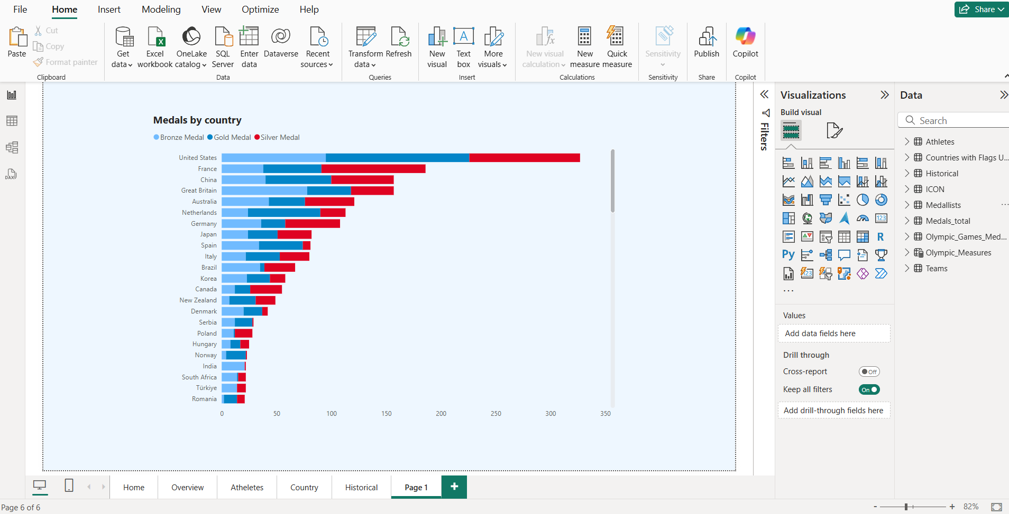

**2.Sport Button Slicer :** It is to **filter Olympic data by sport**. Helps in **comparing performance across different sports**.

* **Button Label:** Sport Name (e.g., Swimming, Athletics, Gymnastics, etc.)

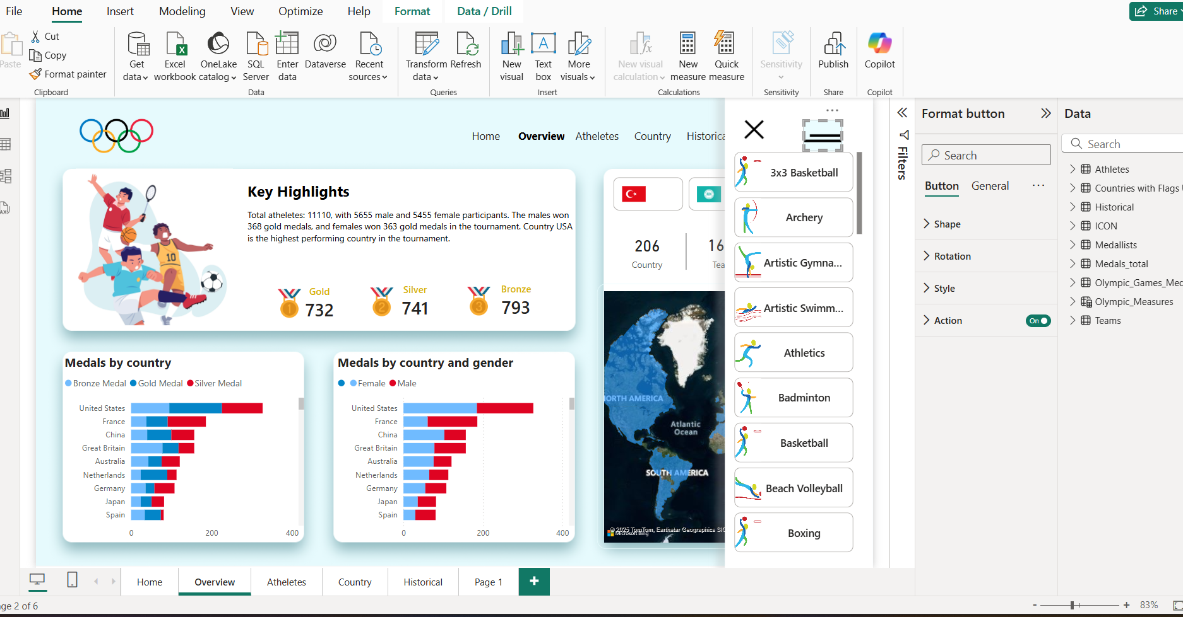

**3.Area Chart :** It helps **analyze the number of medals won year by year.**

* **X-Axis:** Olympic Year
* **Y-Axis:** Number of Medals Won
* **Legend (Optional):** Country Name or Athlete Name
* **Color Fill:** Represents medal count increase or decrease over time.

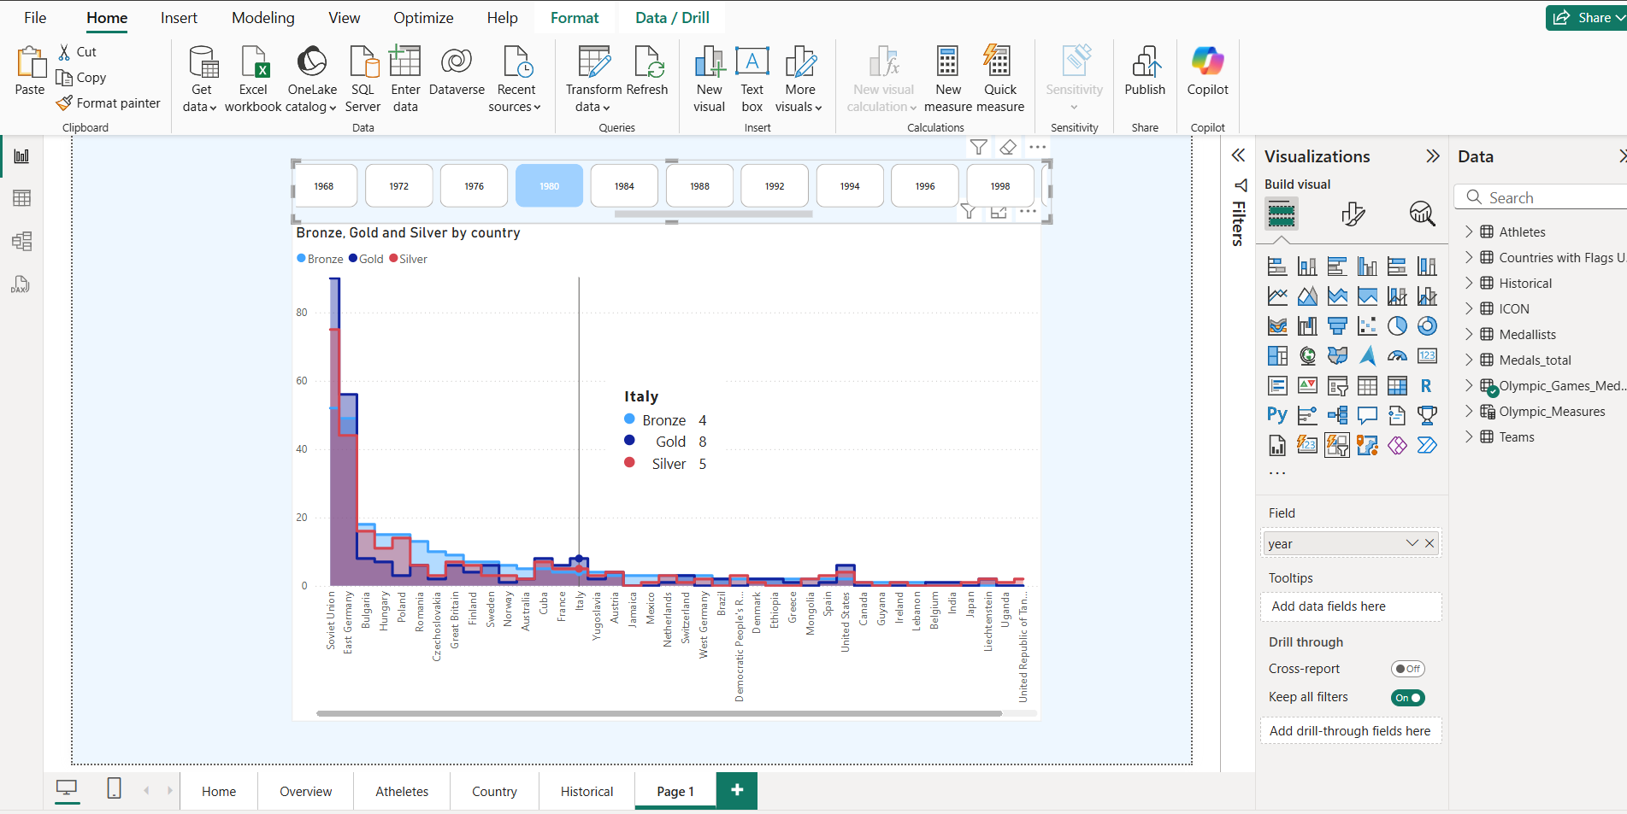

**4.Map Country :** Shows country-wise Olympic performance on a world map.

* **Location:** Country Name
* **Color Gradient:** Number of Medals Won (Darker = More Medals)
* **Drill-Through Filter:** Selected Country.

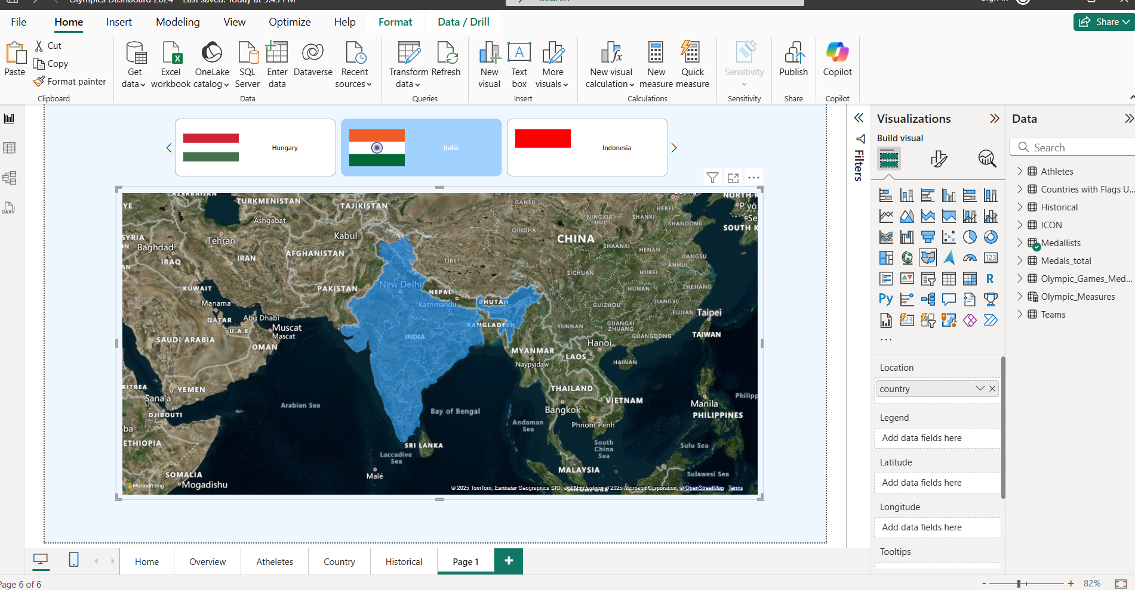

**4.3: Enhancing the Olympics Dashboard with “Slicers” and “Filters”**

**Filters and Slicers** are essential in an **Olympics Dashboard** as they allow users to interact with the data by selecting specific criteria like **year, sport, country, athlete, or medal type**. These features make the dashboard more dynamic and help users analyze Olympic data from different perspectives.

**1. Sport Button Slicer :**

**•Used for:** Enables users to **filter Olympic data by sport**. Helps in **comparing performance across different sports**.

**•Button Label:** Sport Name (e.g., Swimming, Athletics, Gymnastics, etc.)

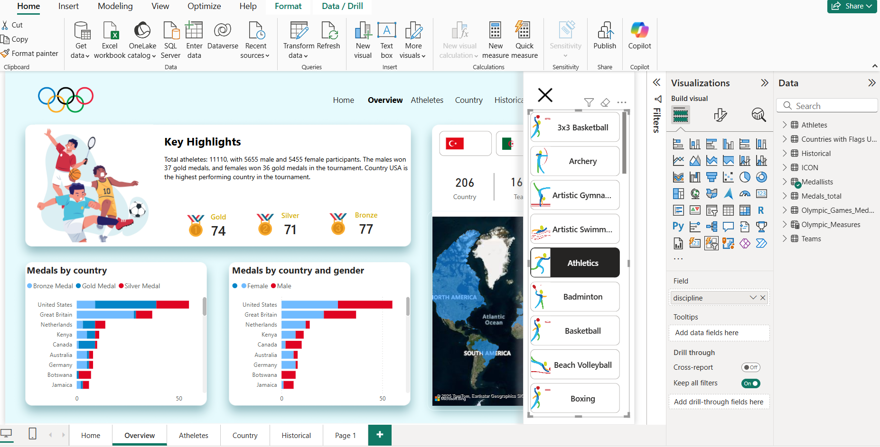

In this slicer i select the “Athletics” , so it’s show all releted data of athletics.

### ****2.Year Slicer (Button or Dropdown) :****

### •Used for: Allows users to select a specific “**Olympic year”** and update all charts. •****Field Used:**** Year

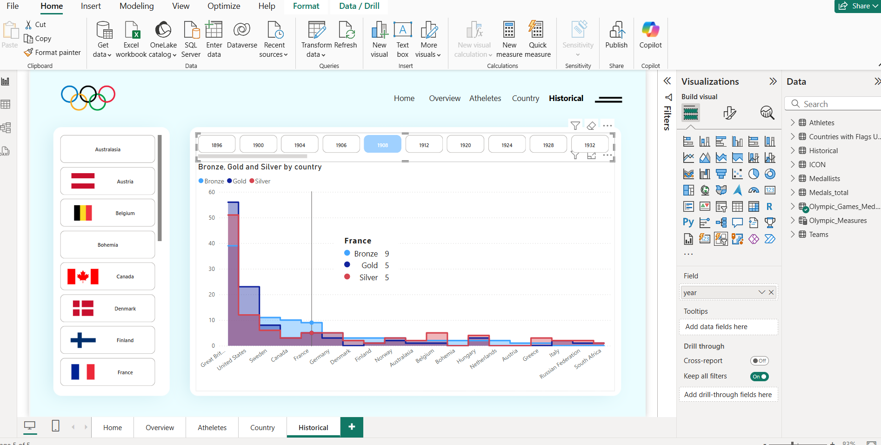

**3.Country Slicer with Flags :**

**•Used for :** A **Country Slicer with Flags** allows users to **select a country** and dynamically filter the **Olympics Dashboard** to show that country's **medal counts, top athletes, and performance trends**.

**•**Adding **flags** makes the slicer more visually appealing and easier to navigate.

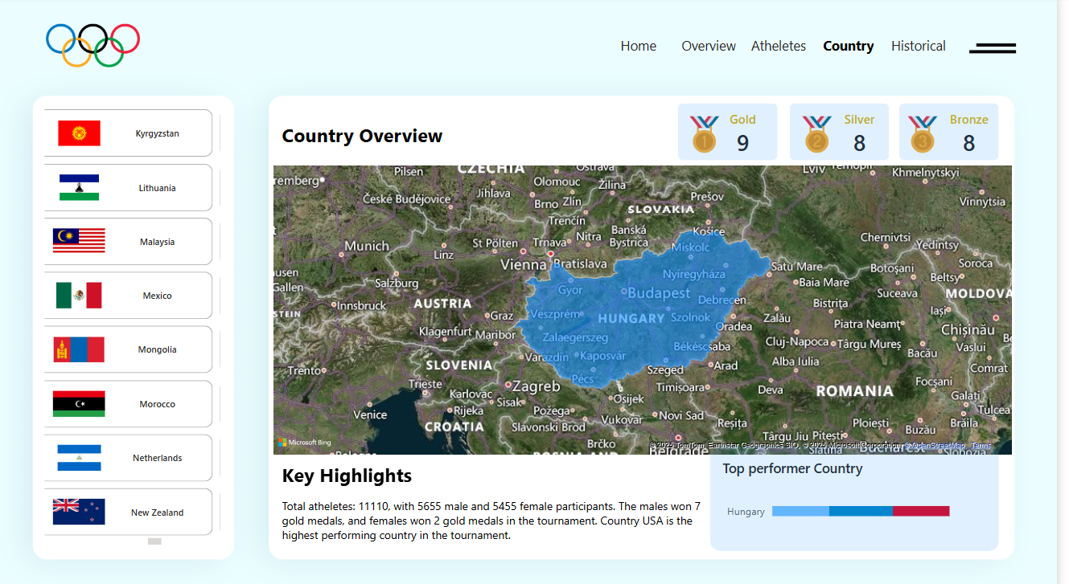

**4.4:** **Test and Publish**

**Step 1: Testing the Dashboard**

**1.Check Data Accuracy**

**•**Verify that **all data points are correctly displayed** in charts and tables.

**•**Cross-check data with original sources (e.g., medal counts, country names, etc.).

2.**Test Filters and Slicers**

**•**Ensure **slicers filter data correctly** (e.g., Year, Country, Sport).

**•**Confirm that **multi-select options** work without errors.

3.**Verify Visuals and Charts**

**•**Ensure each chart displays the **correct data fields**.

**•**Check tooltips, labels, and axis values for clarity.

**4.Test Interactivity**

**•**Click on different elements to ensure **drill-through pages** and linked visuals work smoothly.

**•**Confirm that clicking a country updates all related visuals.

**5.Check Layout and Design**

**•**Verify that all visuals are aligned properly.

**•**Ensure text, titles, and legends are **clear and readable**.

**6.Test Performance**

**•**Check if the dashboard loads **quickly without lag**.

**•**Optimize visuals if the performance is slow.

**Step 2: Publishing the Dashboard**

**•**Save the Power BI File (.pbix)

**•** Click File > Save As and save the file to a safe location.

**•** Make sure the file name is meaningful

(e.g.,Olympics_Dashboard_2024.pbix).

**Step 1:**Click on the **Publish**button, in the **Home**Tab.

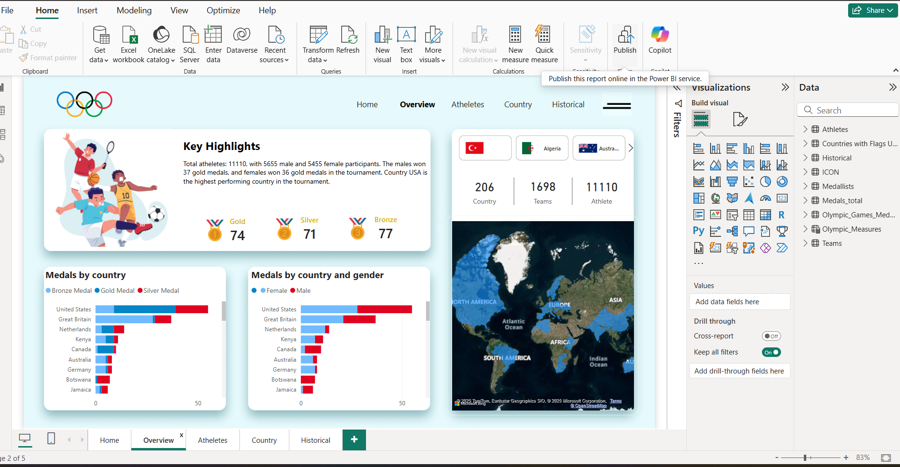

**Step 2:** A dialogue box name, Microsoft Power BI Desktop appears. Click on the Save button.

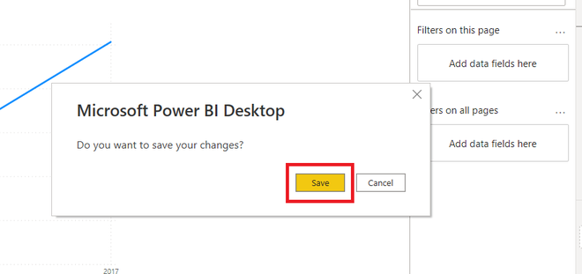

**Step 3 :** Sign In to Power BI Account

**•**Click on Sign In (top-right corner in Power BI Desktop).

**•**Type in your Microsoft Power BI account credentials.

**•**If you don't have an account, sign up at powerbi.com.

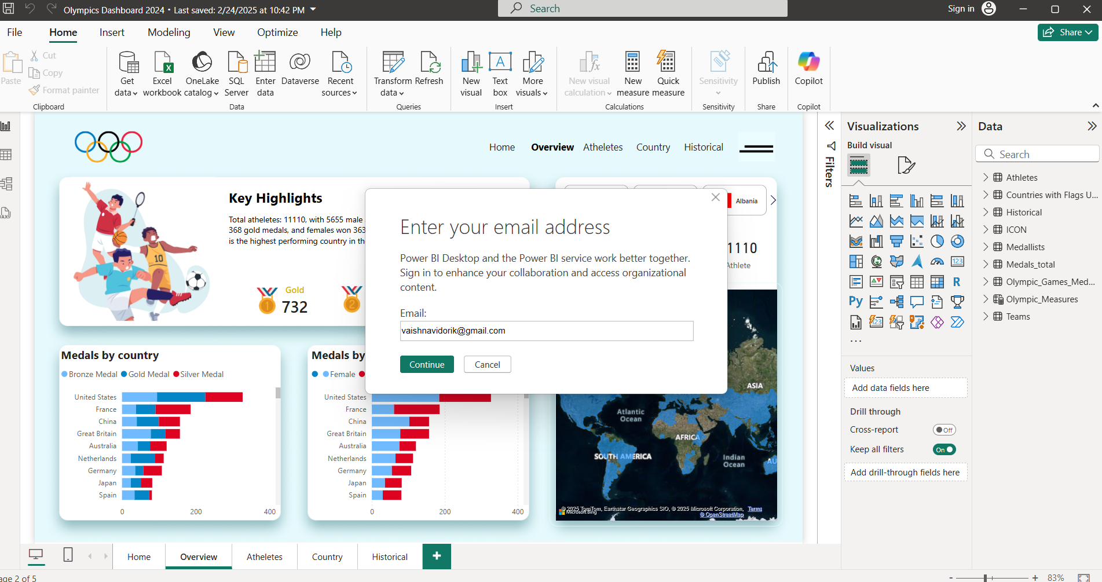

**Step 4:** Choose the correct Workspace

**•**Select a Workspace, in which you want to publish your report.

**•** By default,a workspace name My Workspace is present in Power BI online service.

**•**Click on the **select**button.

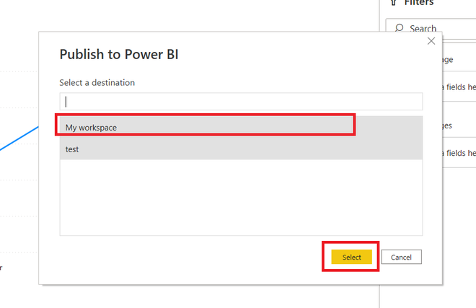

**Step 5:**Now, the report is being published to the Power BI online service. It may take some time to finish.

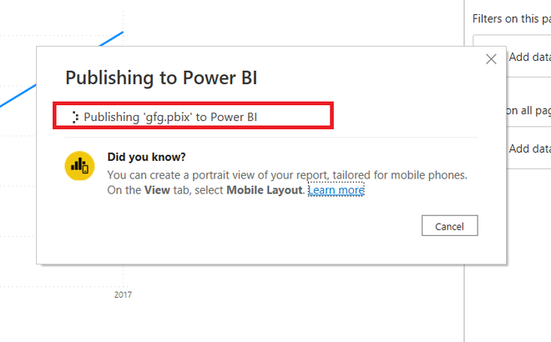

**Step 6:**The report has successfully been published to the Power BI online service. Click on the**Open ‘Olympic Dashboard.pbix’ in Power BI**, to open the report, under online service.

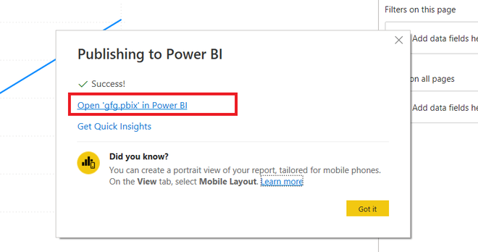

**Step 7:**The report is successfully shown in the Power BI online service.

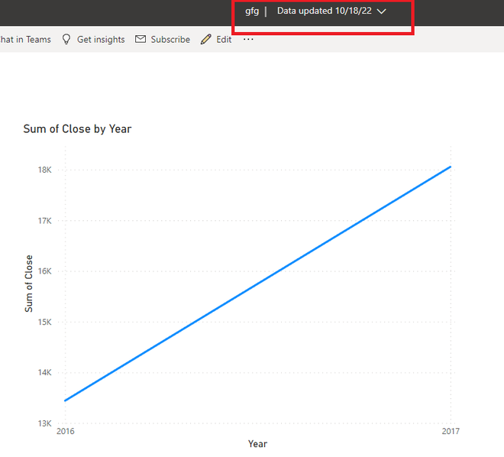

**Step 5: Set Data Refresh (If Applicable)**

**•**Go to Power BI Service and navigate to Datasets.

**•**Go to Settings > Scheduled Refresh.

**•**Define the refresh period (Daily, Weekly, or Hourly).

**Step 6: Share the Dashboard with Stakeholders**

**•**Click on Share at top-right of the dashboard.

**•**Provide email addresses of team members or stakeholders.

**•**Specify permissions (View or Edit) and attach a message, if necessary.

**•**Click on Send to share the link.

**Chapter 5 : Results Interpretation, Reporting**

**5.1 : Results Interpretation, Reporting**

Once the “**Olympics Dashboard”** is built and published, the next step is to **interpret the results** and create a clear **report** for stakeholders.

This ensures that data-driven decisions can be made effectively.

**• Key Interpretation Metrics for Olympics Dashboard**

To analyze Olympic data effectively, consider the following key metrics for meaningful insights:

**1.Total Medal Count**

**•**Displays the **total number of medals** won by each country.  
**•**Helps identify **top-performing nations** in the Olympics.

**2.Gold, Silver, and Bronze Count**

**•**Breaks down the total medal count into **gold, silver, and bronze**.  
**•**Useful for analyzing a country's **strength in achieving top positions**.

**3.Year-Wise Medal Trend**

**•**Tracks the **performance of countries or athletes over time**.  
**•**Identifies periods of **improvement or decline** in performance.

**4.Country Ranking**

**•**Ranks countries based on their **medal counts** or **gold-first rule**. **•**Provides a clear view of **leading Olympic nations**.

**5. Athlete Performance**

**•**Displays top-performing **athletes with the highest medal wins**.  
**•**Helps identify **star players** in different sports.

**6. Sport-Wise Analysis**

**•**Shows which **sports contribute the most medals** to a country’s success.  
**•**Useful for identifying **dominant sports** for specific countries.

**7.Participation Count**

**•**Tracks the **number of athletes or countries** participating over the years.  
**•**Highlights trends in **growing or declining participation**.

**8.Gender Distribution**

**•**Displays the **ratio of male to female participants**.  
**•**Highlights progress in achieving **gender equality in sports**.

**9. Record-Breaking Performances**

**•**Tracks new **Olympic records** set in various sports.  
**•**Useful for highlighting **exceptional athletic achievements**.

### ****5.2: Visualizations for Results (Table Format)****

Below is a structured **table format** for different visualizations used in the **Olympics Dashboard** along with their purpose and key insights.

**5.3: Summary of findings**

* **Synopsis of Results**

A thorough examination of Olympic performance across various years, nations, and sports can be found on the “**Olympics Dashboard**”.

With some nations continuously topping the standings, the medal patterns show a notable increase in participation and accomplishments throughout time.

While the sport-wise distribution reveals which events provide the most medals, the country-wise analysis identifies the best-performing countries. Record-breaking performances are displayed in athlete-level insights, and viewers can investigate certain trends using interactive filters.

All things considered, the dashboard provides **a clear, data-driven picture of Olympic history**, assisting stakeholders in effectively analyzing historical performance and forecasting future patterns.

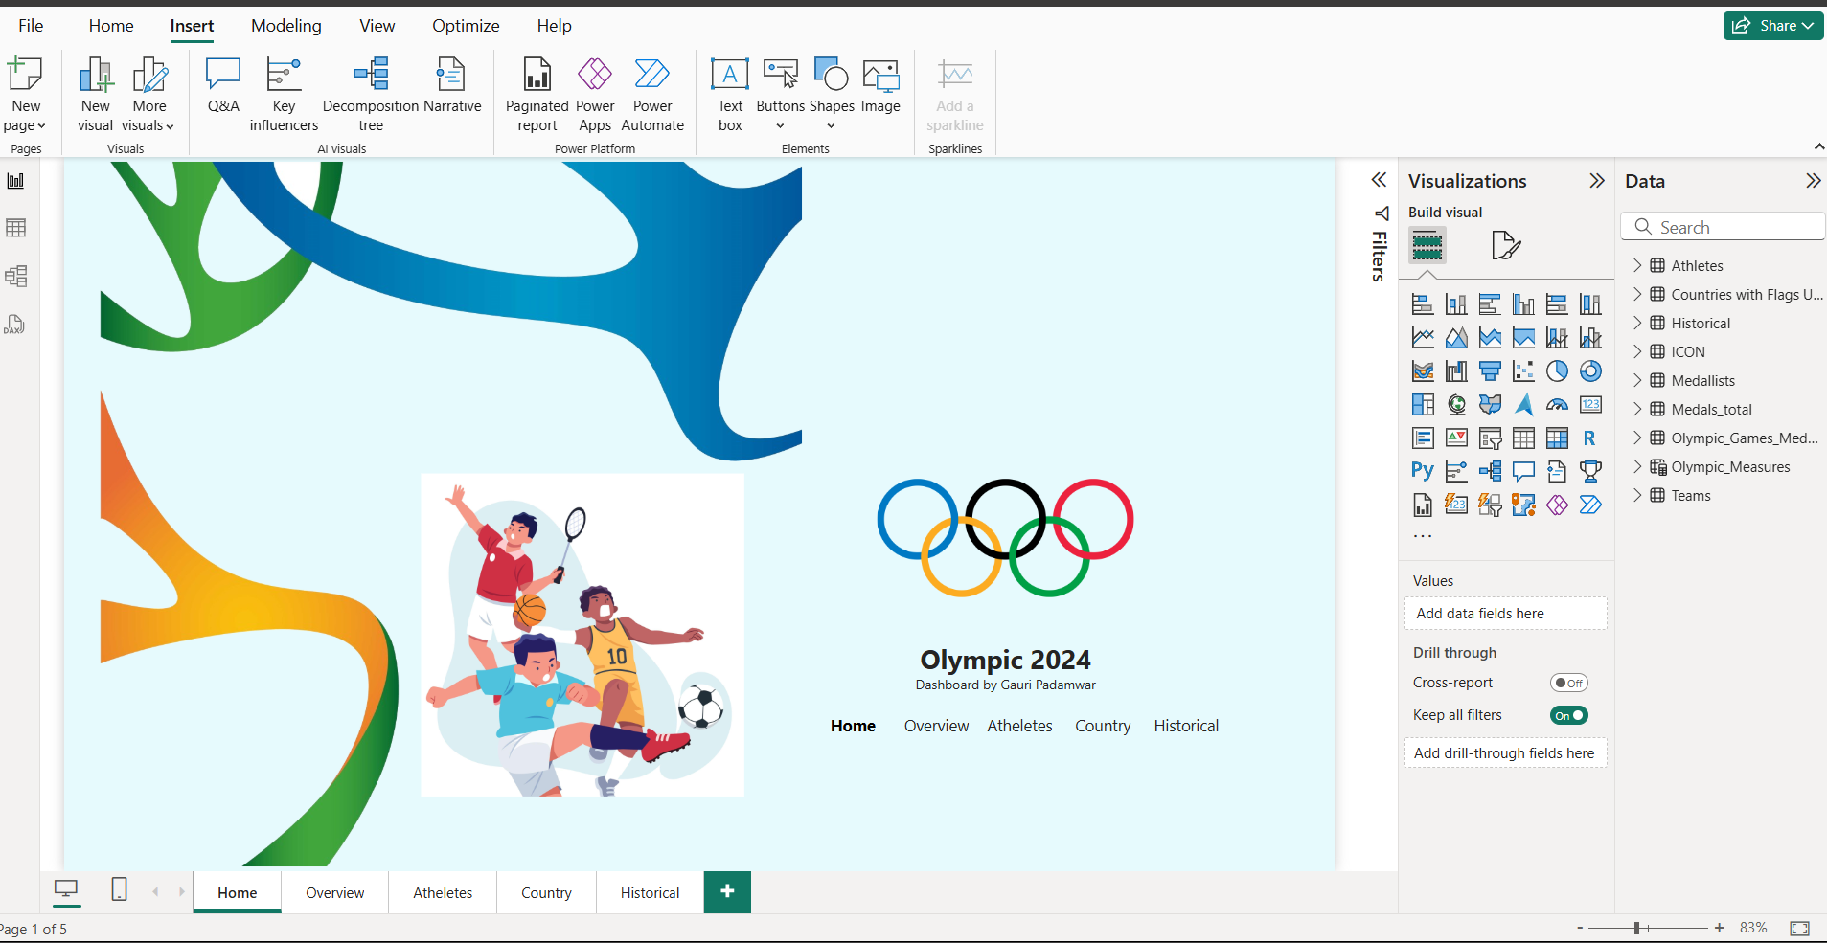

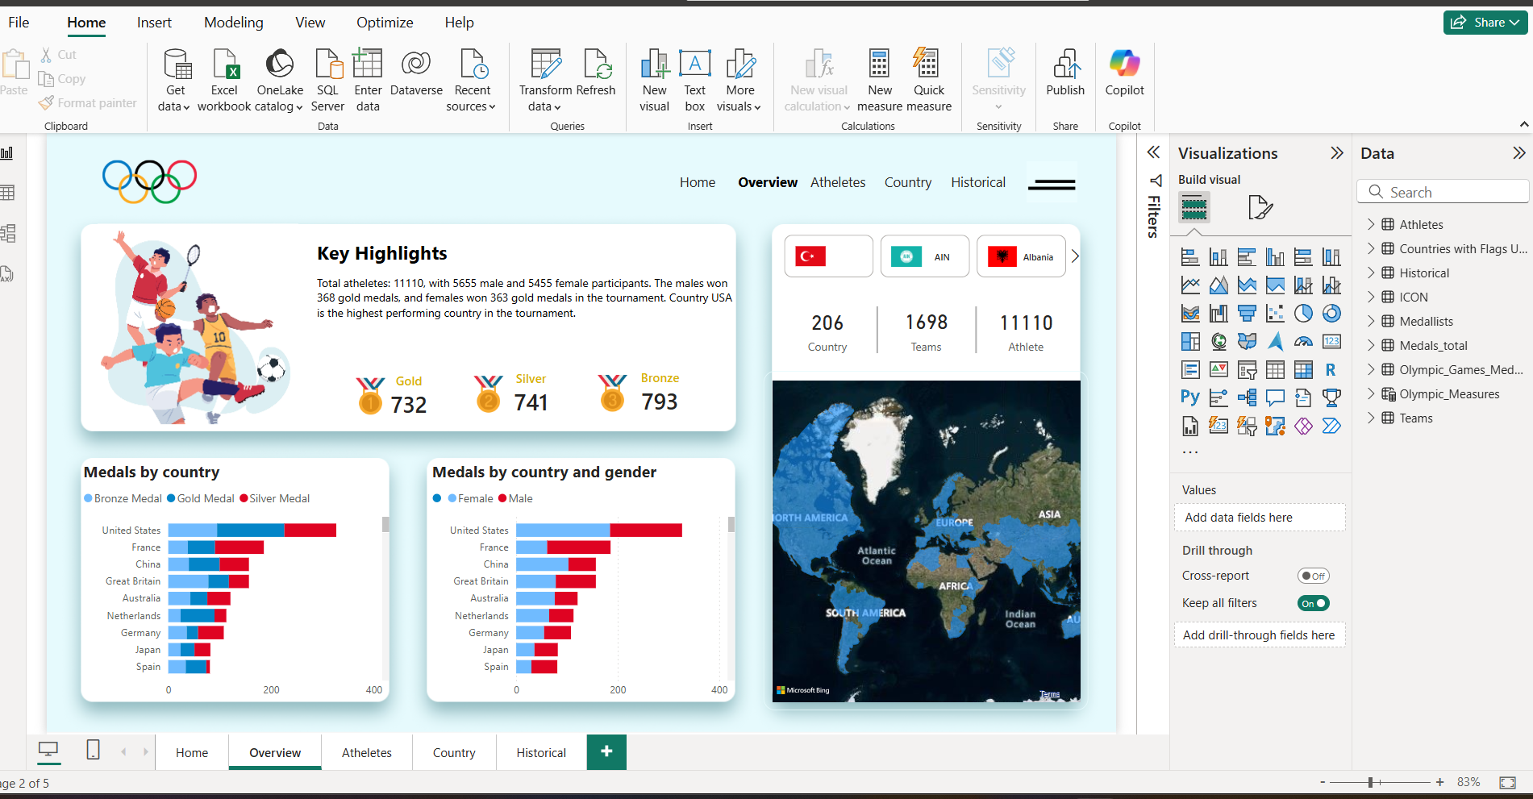

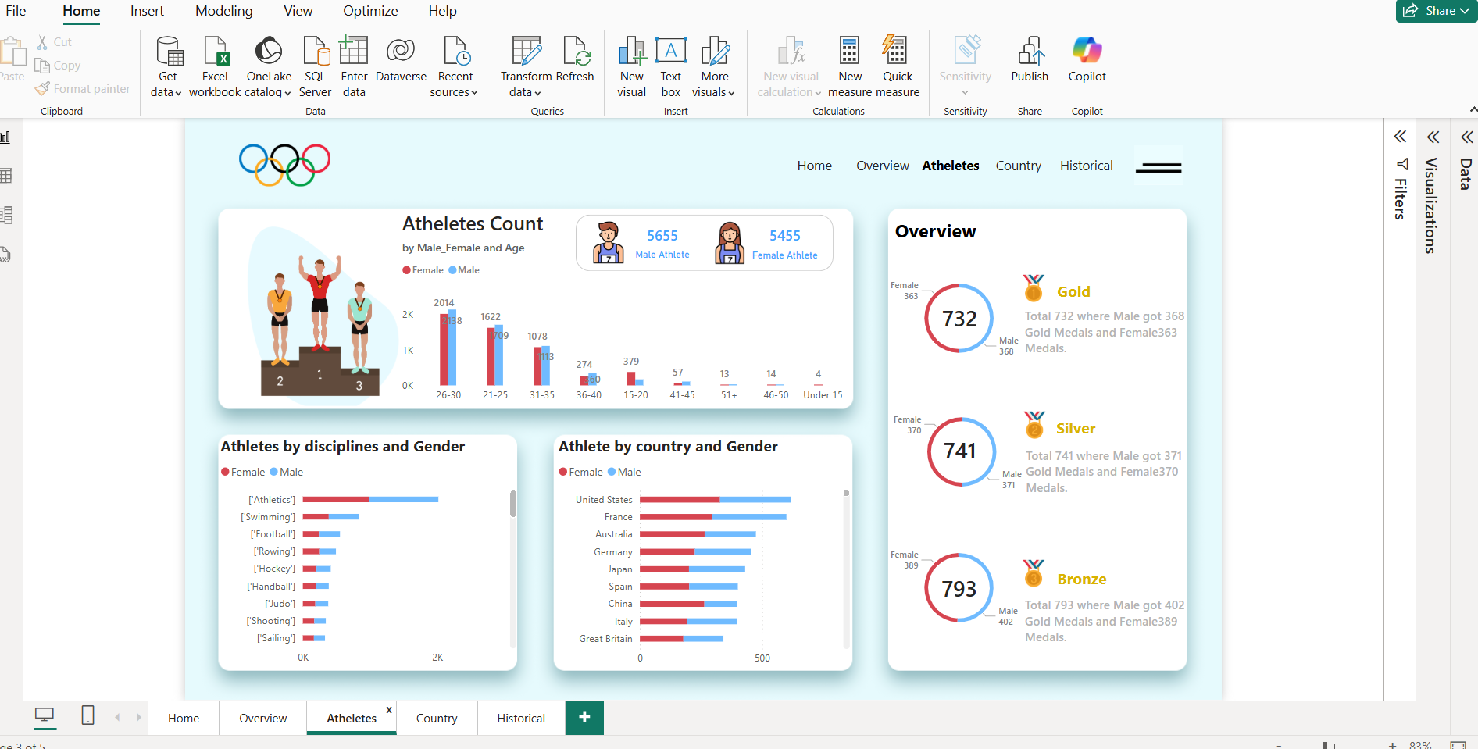

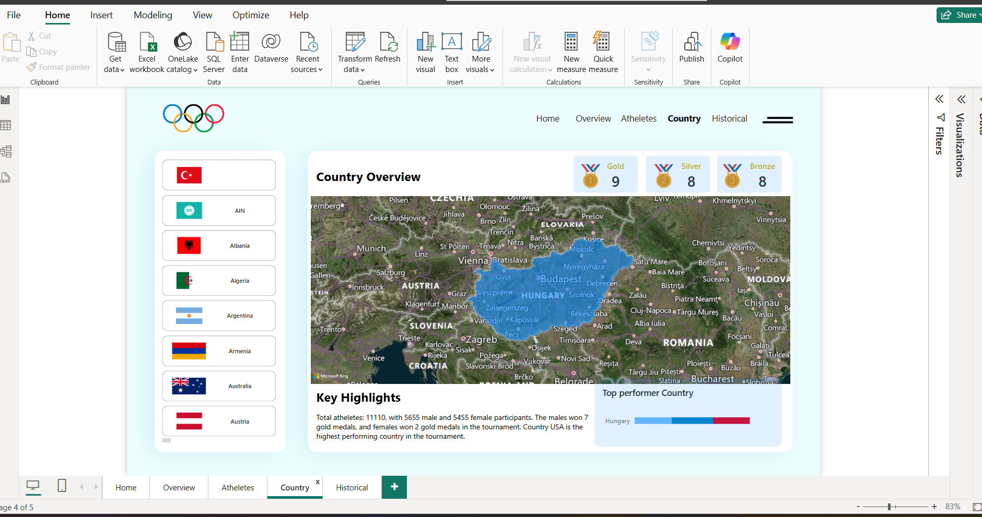

**Chapter 6 : Conclusion and References(Future Scope)**

**6.1: Recommendations**

1.Suggestions To improve athlete performance, nations should invest in sports training facilities.  
2. To increase medal tallies, lagging sports should receive more attention.  
3. Data-driven approaches can be used by governments and sports groups to choose and develop athletes.  
4. Funding and sponsorship should be distributed according to the likelihood of winning medals.  
5. To find future top-performing athletes, use AI and predictive analytics.

**6.2 :Future Enhancements**

1. Data changes in real time for current Olympic competitions.  
2. Incorporating machine learning models to forecast medal patterns in the future.  
3. More thorough performance monitoring and athlete profiles.  
4. Improved dashboard that is mobile-friendly for convenient access across all devices.  
5. Using historical comparison charts to monitor performance over several decades.

**6.3 : Communicating Results to Stakeholders**

* Use **interactive dashboards** to present findings visually.
* Provide **summary reports with key insights** and recommendations.
* Organize **virtual meetings or presentations** for decision-makers.
* Share **PDF or PowerPoint exports** of the dashboard for easy reference.
* Allow stakeholders to **interact with the data using filters and slicers**.

### ****Conclusion****

The **Olympics Dashboard** provides a powerful and interactive way to analyze Olympic data, offering valuable insights into country-wise performances, sport-specific trends, and athlete achievements.

By leveraging **Power BI**, this project successfully visualizes complex data, making it easier for stakeholders to understand historical trends and make informed decisions.

With the integration of **filters, slicers, and interactive charts**, users can explore the data dynamically, identifying key patterns and areas for improvement.

This dashboard not only serves as a **historical reference** but also lays the foundation for future enhancements, such as **real-time updates, predictive analytics, and AI-driven insights**.

### ****6. 4 : References****

#### ****🔹 Research Papers****

1. **Smith, J. (2020)** –**Data Analytics in Sports**: A Review of Olympic Performance Trends. International Journal of Sports Analytics.
2. **Brown, A., & Lee, C. (2019).** Machine Learning Applications in Predicting Olympic Medal Winners. Journal of Data Science & Sports.
3. **Guttmann, A. (2002)** – *The Olympics: A History of the Modern Games.*Analyzes the historical development and controversies surrounding the Olympics.
4. **Williams, T. (2019)** – "The Role of Power BI in Interactive Data Reporting". Journal of Business Intelligence, Vol. 12(4), pp. 67-80.
5. **Wexler, S., Shaffer, J., & Cotgreave, A. (2017)** – The Big Book of Dashboards: Visualizing Your Data Using Real-World Business Scenarios. Wiley

#### ****🔹 Websites****

1. **Olympics Official Website** – [www.olympics.com](https://www.olympics.com)
2. **Power BI Documentation** – <https://docs.microsoft.com/en-us/power-bi>
3. **Kaggle Datasets** – <https://www.kaggle.com>
4. **Statista - Olympic Statistics** – [www.statista.com](https://www.statista.com)